Access form Accessible Survey Builder
Design Document

Version 1.0



Group Id: F25PROJECTC0317

Supervisor Name: Abdullah Qamar

Revision History
Date (dd/mm/yyyy) | Version | Description | Author
15\02\2026 | 1.0 | The Accessible Survey Builder is a web application that lets users easily create and manage surveys while making sure everyone, including people with disabilities, can use it. Most survey tools don’t really consider accessibility, so some people have a hard time participating. This project aims to make a simple and user-friendly platform where anyone can design surveys, collect answers, and generate reports. By focusing on accessibility, it helps everyone take part and makes the whole process easier and more inclusive. | BC220410808

Table of Contents

- Introduction of Design Document
- Entity Relationship Diagram (ERD)
- Sequence Diagrams
- Architecture Design Diagram
- Class Diagram
- Database Design
- Interface Design
- Test Cases

- Introduction of Design Document
This design document is basically created after the SRS document, which is for the project Access Form – Accessible Survey Builder. Basically, SRS tells us what the system or app will do and how it will do it, whereas the design document tells us how the system will be designed and how it will look.

The main purpose of this document is that we can see how our project will actually look before we start coding and issues appear. It converts all functional and non-functional requirements into details in diagrams, system designs, and models, which define overall architecture, data structure, component interaction, and user interface.
This document contains many important design elements such as Entity Relationship Diagram, which represents the database structure; Sequence Diagram, for flow of activities of each use case; Architecture Design Diagram, which shows system structure; Class Diagram, which defines system classes and their relationships; Database Design, to describe data storage; Interface Design, to visualize graphical user interfaces; and Test Cases, to verify system functionality.
Since Access Form is an accessibility-focused web application, special attention is given during design phase to ensure accessibility such as keyboard navigation, screen reader compatibility, ARIA attributes, and high contrast themes. The main purpose of designing these features at this stage is so that issues can appear.
This design phase plays a critical role in software development life cycle because it acts as a bridge between requirement analysis and system implementation. It helps developers clearly understand system modules, data flow, and interactions before coding.
The benefits of the design document are system clarity, early identification of potential issues, better maintainability, and efficient development planning. The Access Form system can be developed in a more organized, reliable, and user-focused manner while ensuring accessibility for all users.
- Entity Relationship Diagram (ERD) (To be developed using Microsoft Visio or any other drawing software of your choice)
An Entity Relationship Diagram (ERD) is a diagram that shows us how a system's data is connected. This diagram helps in understanding the important things (entities) within the database, their characteristics (attributes), and their mutual connections (relationships). Before developing software, an ERD is created so that data requirements can be clearly understood and the database can be designed correctly.
In the Access Form Accessible Survey Builder system, the ERD displays key components such as Users, Surveys, Questions, Responses, Accessibility Profiles, and WCAG Compliance Reports. This diagram explains how users with different roles interact with surveys, where people's answers (responses) are saved, and how accessibility settings and reports are managed separately. The purpose of keeping accessibility-related data separate is to ensure there are no errors in the system, no redundant data is collected, and the system can be easily scaled when needed.

Figure 2.1
- Sequence Diagrams (To be developed using Rational Rose or any other drawing software of your choice)

A Sequence diagram means a picture that tells how different parts of the system are talking to each other when and how. From this, we get to know that when a user starts any work, which module inside the system will run first and which one later. This diagram is very important for understanding the working style (logic) of the system. The benefit of this is that the responsibility of every component becomes clearly visible to us and it also confirms that the whole system is running in the exactly correct sequence.
In Access Form Accessible Survey Builder, we have used sequence diagrams so that tasks like login, making a survey, and submitting responses can be understood step-by-step. Every diagram focuses on some specific tasks (use case) and shows how accessibility services and the database work together to create a better and easy environment.

- Sequence Diagram – User Registration & Login
This sequence diagram shows how the Admin, Form Creator, and Respondent register and login in the system. In this, the complete path is shown that when a user goes to the login interface, how the authentication service checks their details. As soon as the login is correct, the user's set accessibility settings (preferences) are loaded immediately. The most important thing in this diagram is that accessibility has been taken care of at every step of login, so that people who use a keyboard or screen reader do not face any problem in logging in.

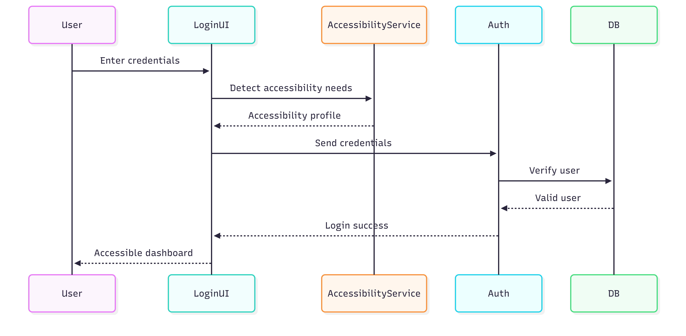
Figure 3.1

- Sequence Diagram - Accessible Survey Creation (Form Creator)
This sequence diagram explains how a Form Creator creates a new survey, showing that when a creator uses the survey builder interface, how their interaction happens with the accessibility engine and the database; the diagram emphasizes how the accessibility settings of the survey, such as ARIA labels, contrast modes, and keyboard support etc., are automatically applied even before saving or publishing, and in this way, it is ensured from the very beginning that the survey being created is easy for everyone to use.

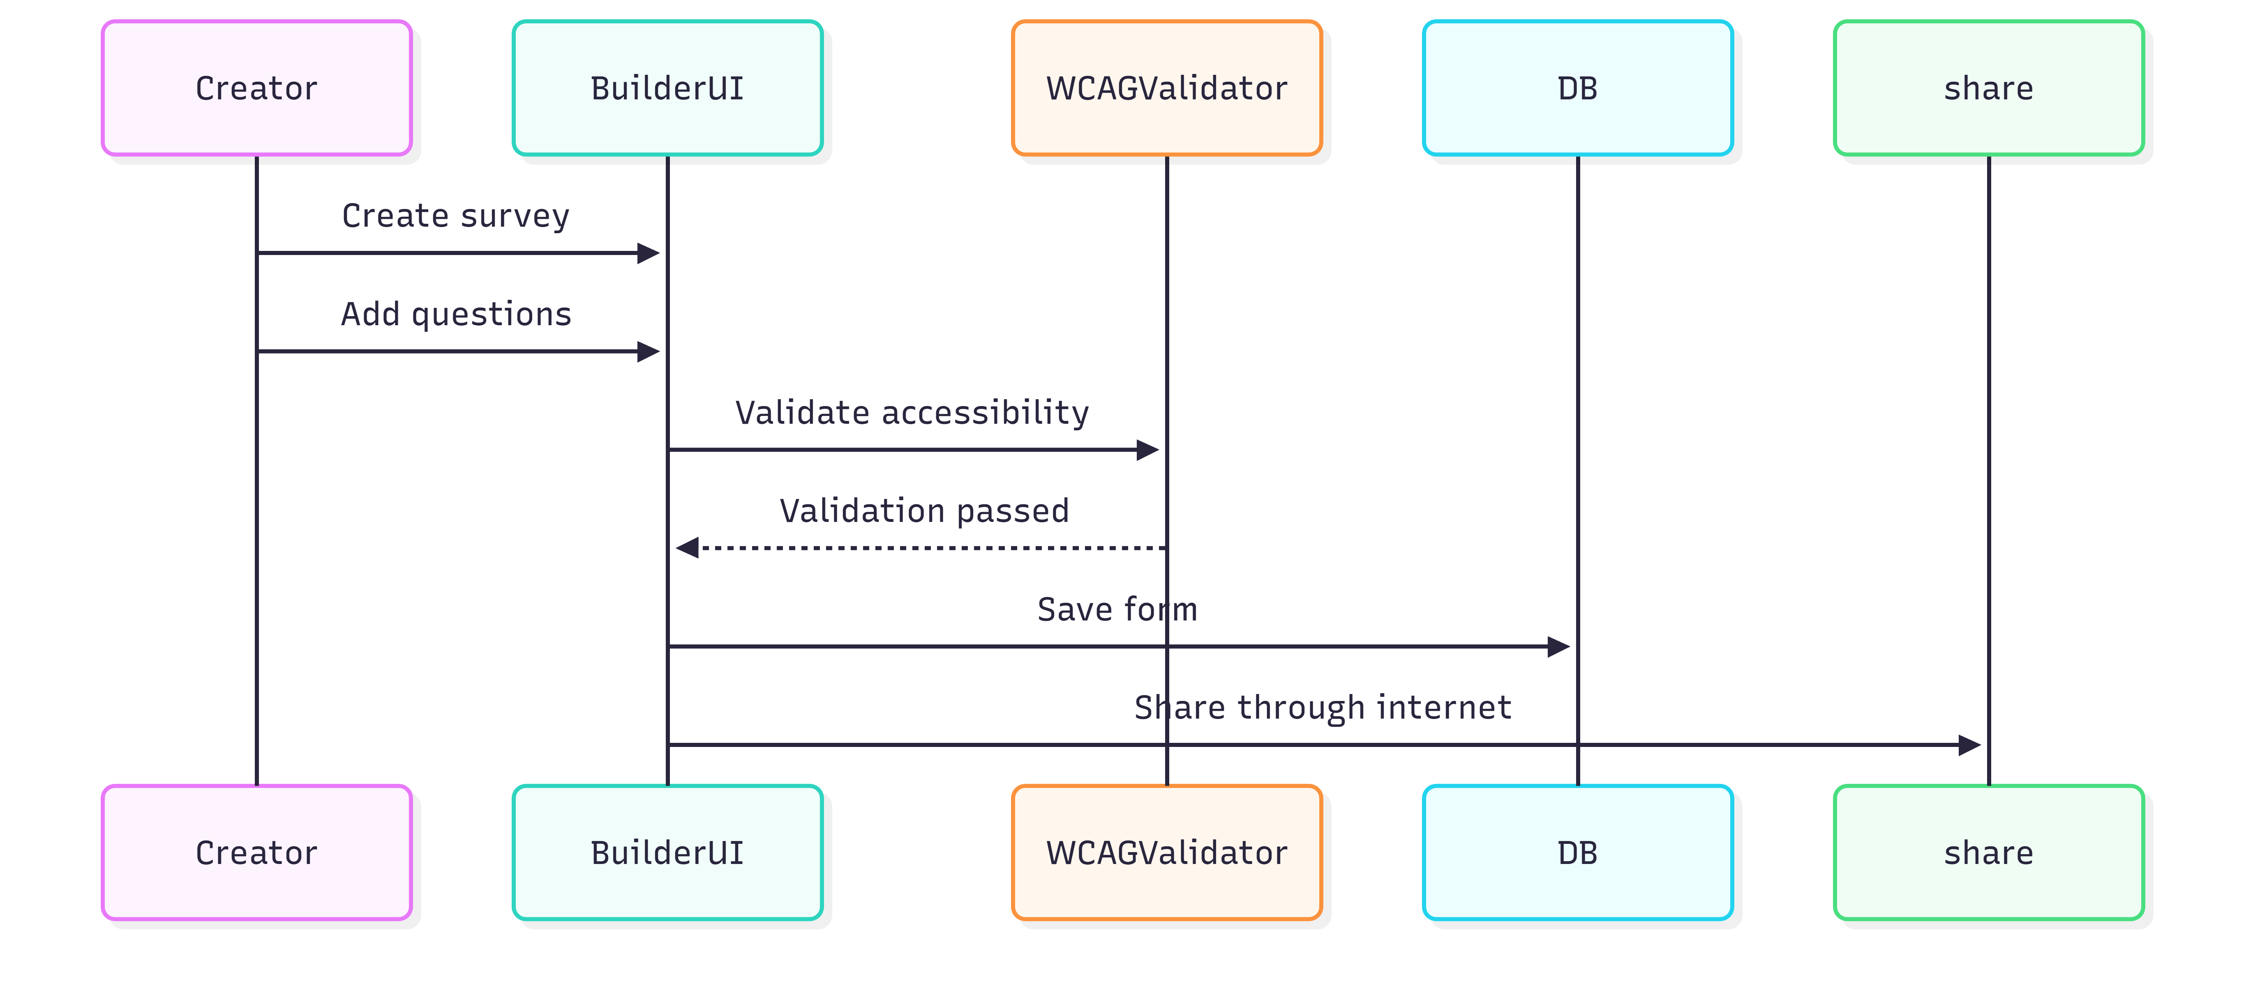
Figure 3.2
- Sequence Diagram – Survey Participation & Response Submission (Respondent)
This sequence diagram shows how a Respondent fills and submits a survey using a keyboard or voice input. In this, it is explained how the system changes (adapts) the interface according to the user's accessibility profile. When the user gives an answer, the system checks those answers, and if there is any mistake, it is also told in an easy way. At the end, all responses are saved in the database. The entire process is designed in such a way that feedback and confirmation messages also reach the user in a correct way and easily.
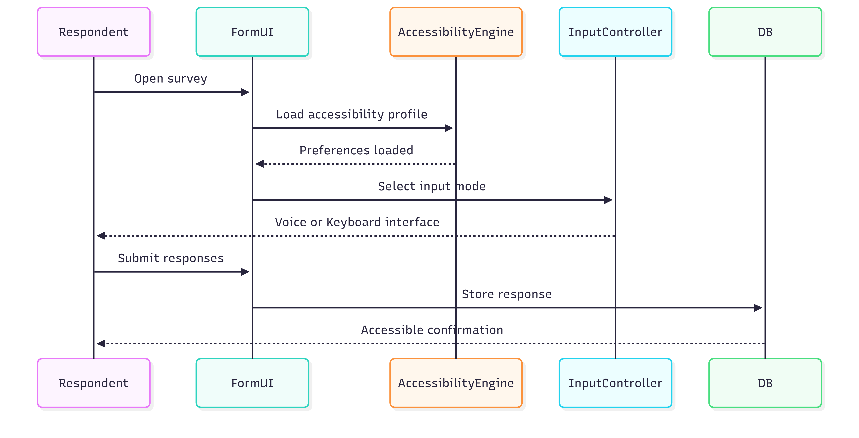
Figure 3.3
- Sequence Diagram – Analytics & WCAG Accessibility Evaluation
This sequence diagram shows how the analysis of survey responses occurs in the system and how accessibility principles (WCAG) are checked. It illustrates how, when an Admin or Form Creator opens the dashboard, data is retrieved from the database and how the accessibility evaluation service begins its work. Its real purpose is to ensure that the results being presented can be easily understood by everyone.
The diagram also explains how the survey is tested according to WCAG rules before or after being published. The system automatically generates accessibility reports and indicates whether the survey meets the standards or not. In this way, the work of checking data and maintaining accessibility continues side by side, ensuring the system always remains optimal for every user.

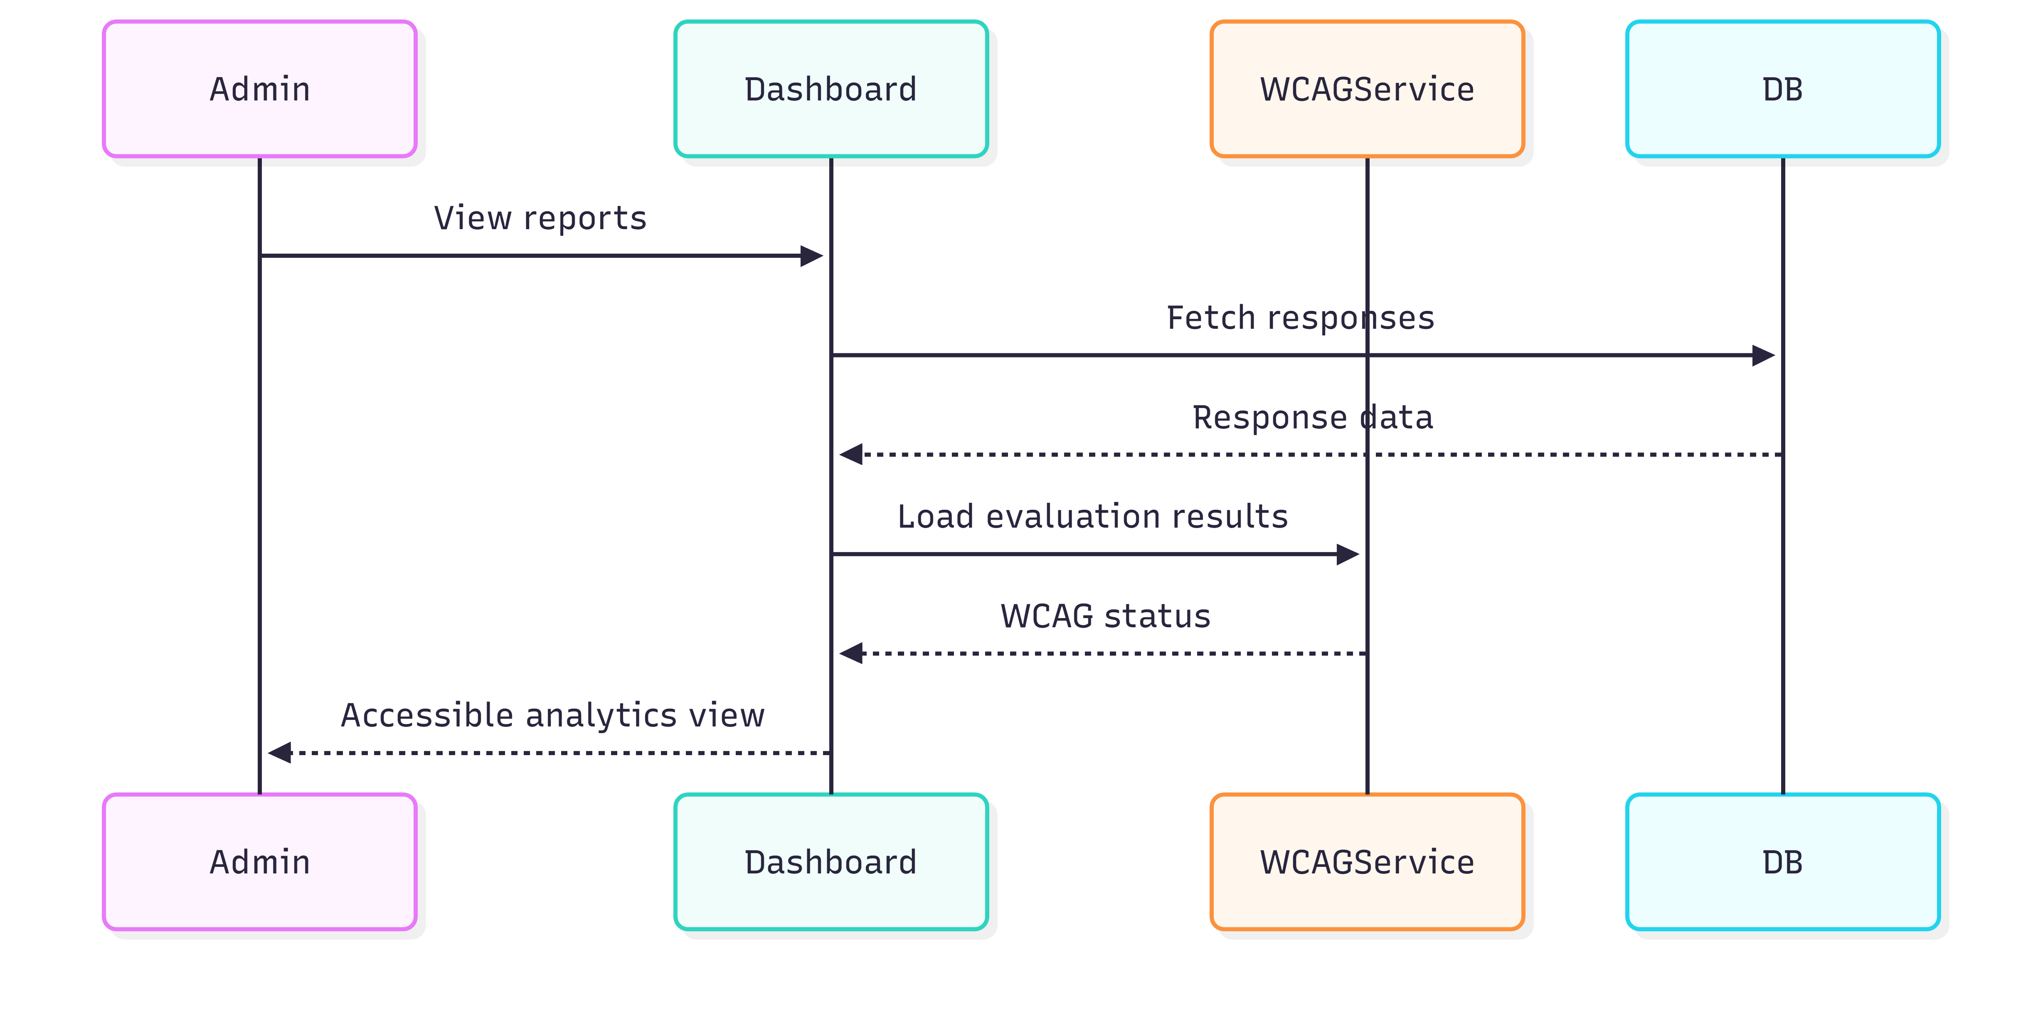
Figure 3.4
- Architecture Design Diagram
The Architecture Design Diagram is a main blueprint of our AccessForm system, which clarifies its entire structure. With the help of this diagram, it becomes easy for us to understand how the different layers of the system interact with each other. Its real purpose is to make it easy to scale and maintain the system, because a separate responsibility has been fixed for every part.
Access Form has been built on a tiered architecture, which consists of three main layers:
- Presentation Layer: Its focus is only on the user interface so that accessibility can be ensured at every level.
- Business Logic Layer: This is the core part of the system which controls the survey logic and all accessibility services.
- Data Layer: The job of this layer is to store data in the database securely and persistently.
By dividing the work into layers in this way, the security of the system improves and it becomes easy to strictly follow accessibility standards throughout the entire system.

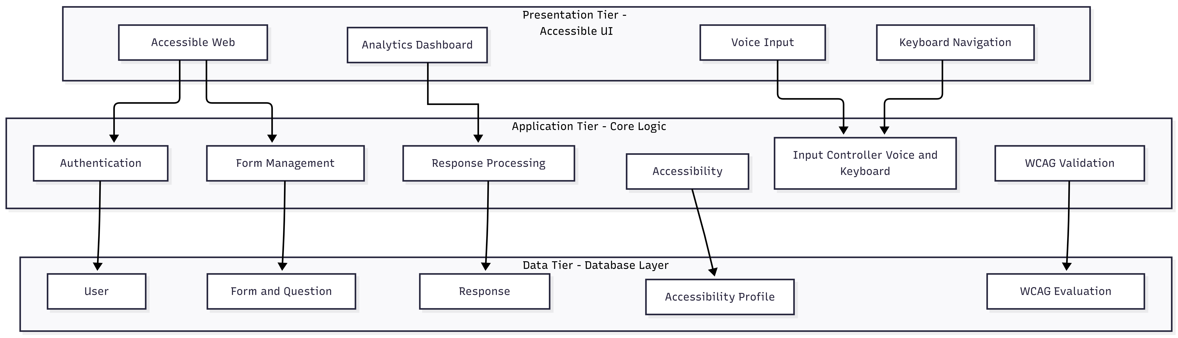
Figure 4.1
- Class Diagram

A Class Diagram is basically a blueprint of our system that tells which Classes will be in the code, what their characteristics (attributes) will be, and how they will be connected to each other. This diagram is very important for developers because it shows how the system's work has been divided into different parts and how these classes interact with each other at runtime.
In the Access Form system, some main classes have been created within the Class Diagram, such as User, Admin, Form Creator, Respondent, Survey, and Response. The best thing about this design is that we have kept the logic related to accessibility in completely separate classes. The benefit of this modular approach is that it becomes easy to manage the system and accessibility rules are applied in the same way throughout the entire application.

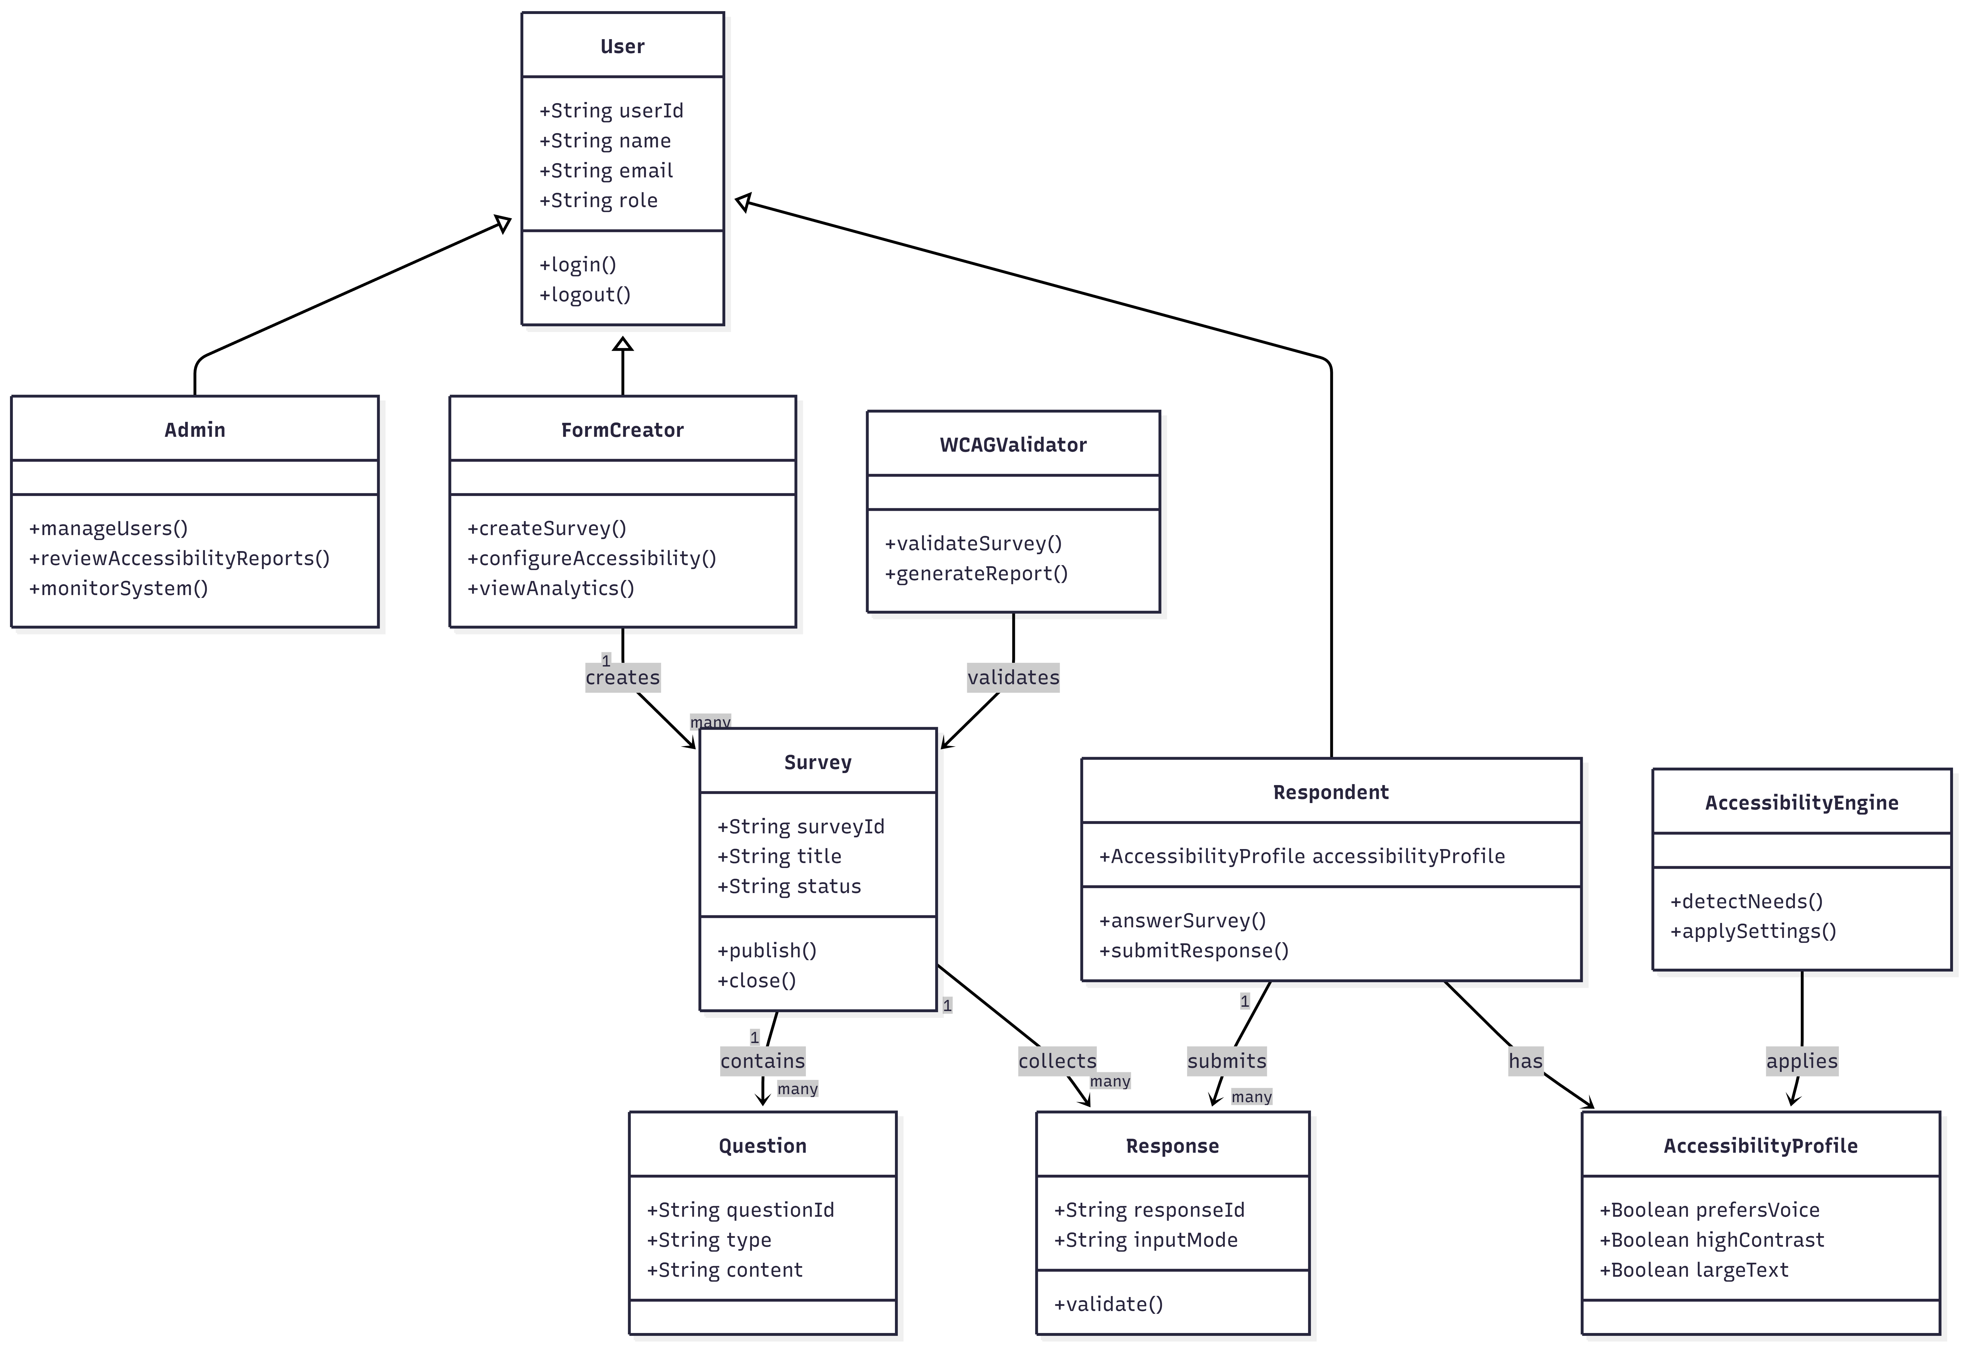

Figure 5.1

- Database Design

The Database Design Diagram is a physical map of our database, which shows the relationship between tables, fields, and their primary and foreign keys. This diagram is actually a detailed version of the ERD, which acts as a blueprint for actually implementing the database. Its benefit is that there are no errors in the data (integrity), redundant data is not collected, and retrieving information from the database becomes quite fast.

For Access Form, the database design includes tables for users, surveys, questions, and responses. We have done a special thing by creating separate tables for accessibility profiles and WCAG compliance reports. In this way, data remains organized much better and the system can track accessibility features completely separately. This structured approach is very important for expanding the system in the future (scalability) and maintaining it for a long time.

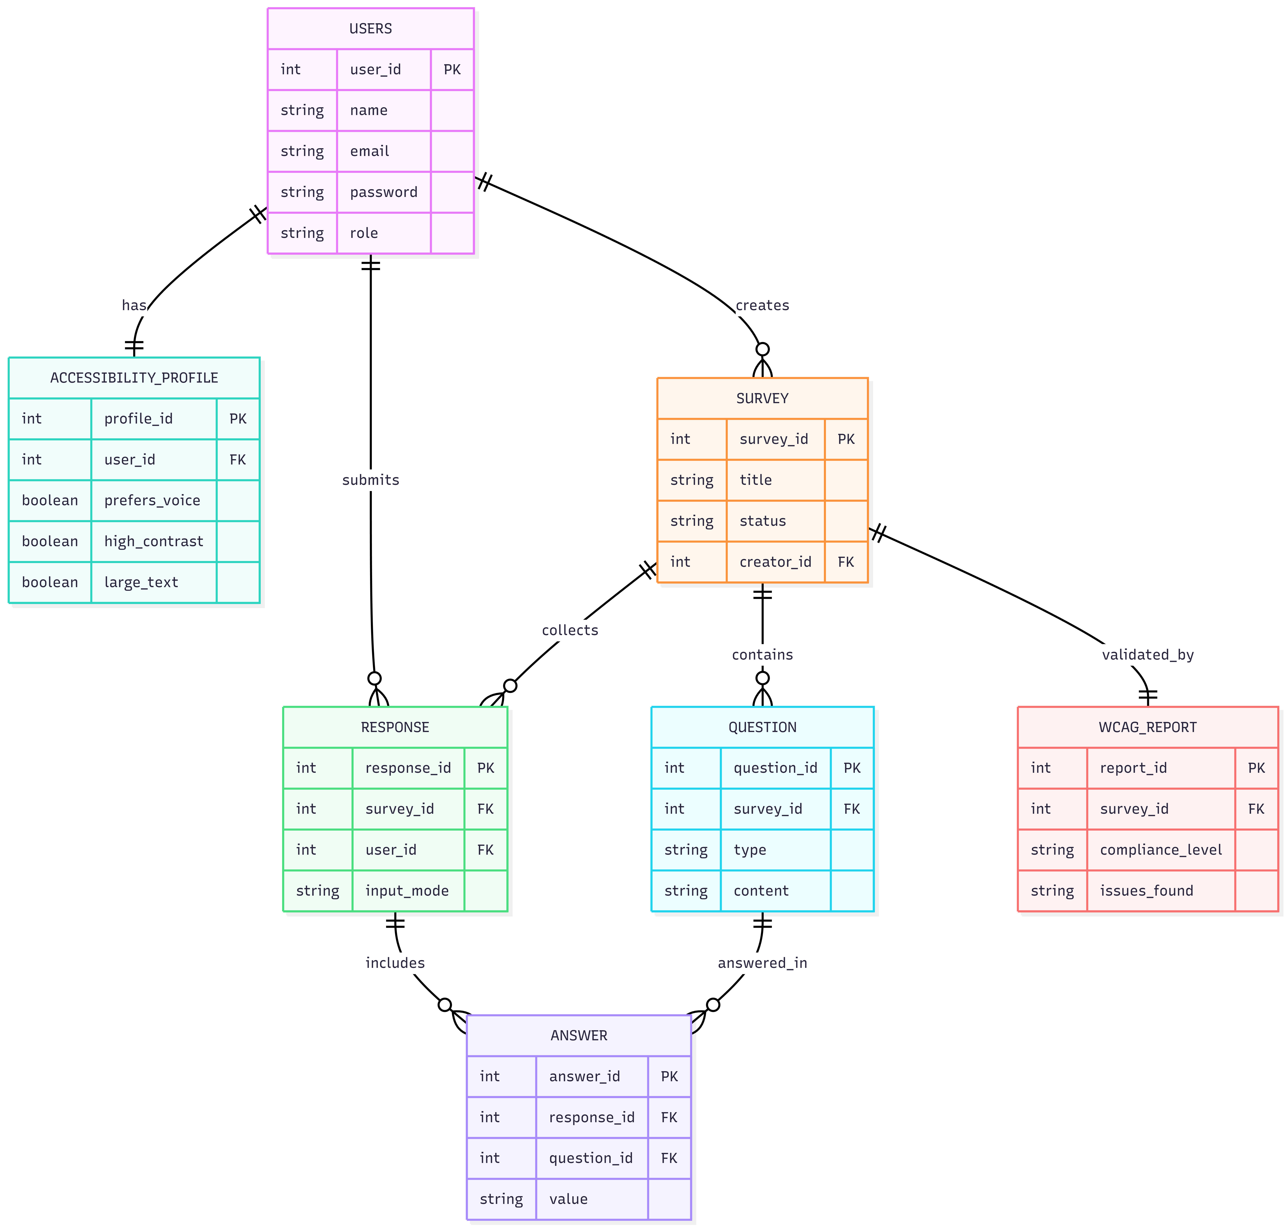
Figure 6.1

- Interface Design

- GUI–1: Accessible Login & Registration Screen
Description:
This interface provides the facility for Admin, Form Creators, and Respondents to login or register through an accessible form. While designing this screen, special care has been taken so that it can be operated entirely by keyboard (keyboard navigation). Clear labels and ARIA roles have been used in it so that screen-reader users do not face any problem. If an error occurs during login, then along with showing the error messages, they are also explained in writing, so that every type of user can understand the matter.
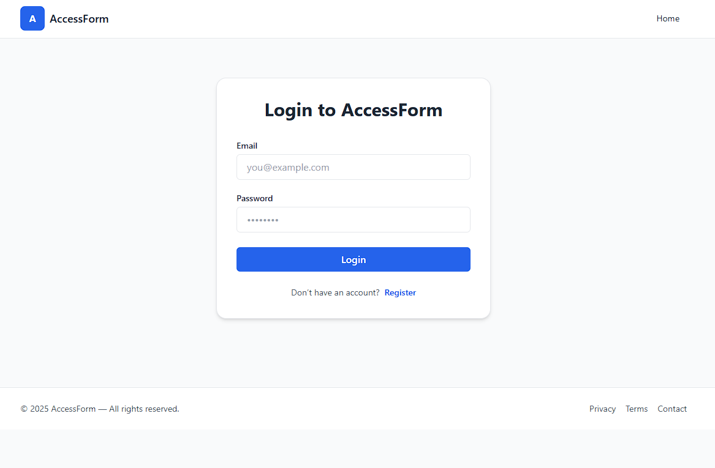
Figure 7.1

- GUI–2: Survey Builder Interface (Form Creator)
Description:
This interface has been created for Form Creators so that they can easily design surveys with the help of a drag-and-drop builder. In this, different types of questions can be included, such as multiple choice, text input, and rating scales. For every question, accessibility settings, for example ARIA labels, alt text, and contrast modes, have been given as an option to set. Its purpose is simply that every survey being created should be according to WCAG standards and everyone can use it without any hurdle.

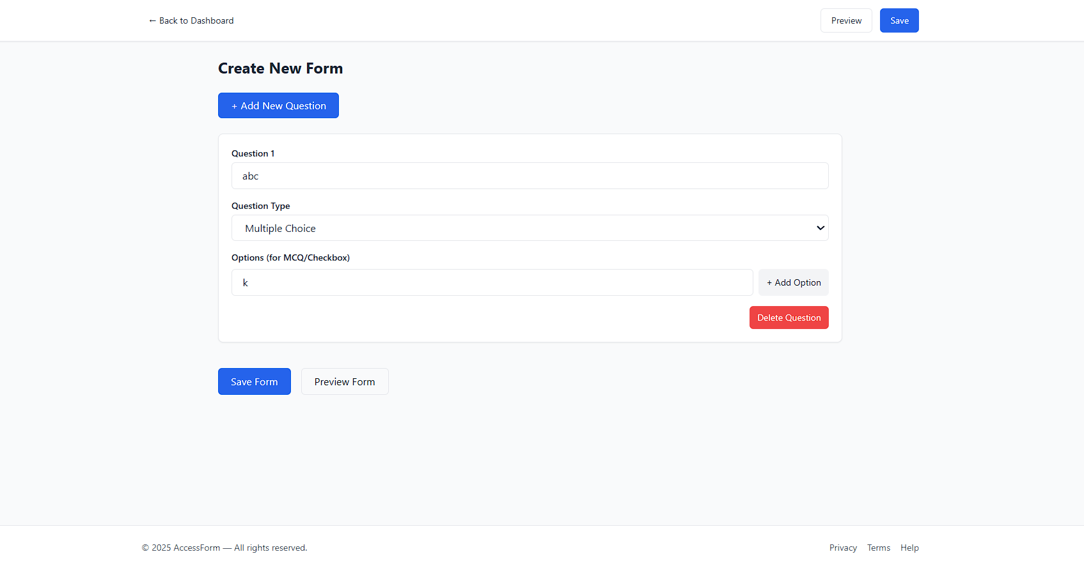
Figure 7.2

- GUI–3: Survey Filling Interface (Respondent)
Description:
This interface allows respondents (survey takers) to fill out the survey using a keyboard or voice. The system automatically adjusts the interface according to the user's accessibility profile. During the completion of the survey, clear progress indicators (which tell you how far you have reached), accessible validation messages, and ARIA announcements guide the user.

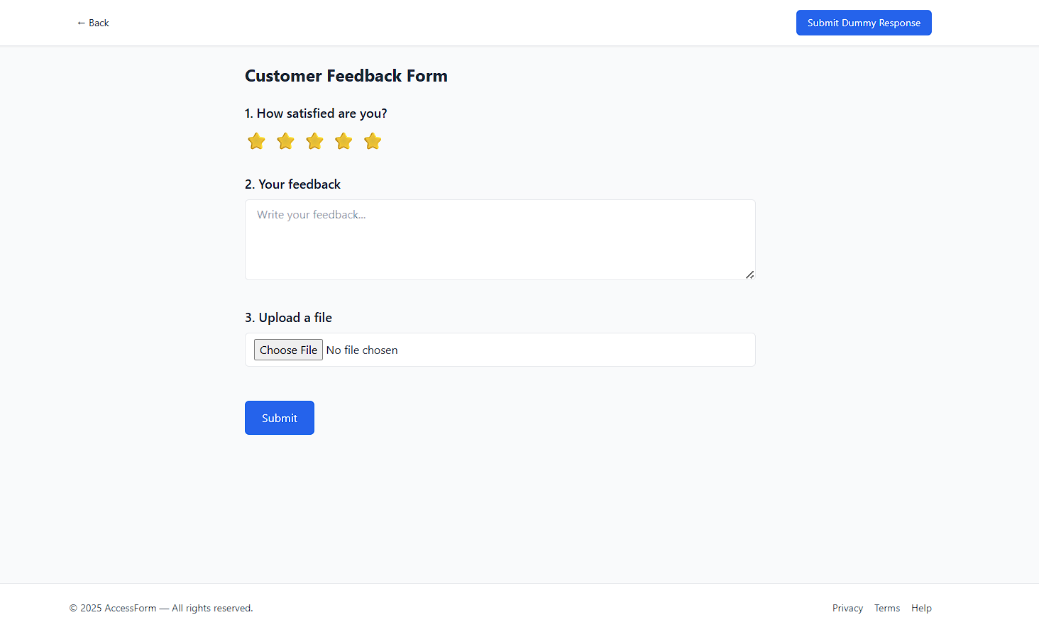
Figure 7.3
- GUI–4: Analytics & Accessibility Dashboard (Admin / Creator)
Description:
This dashboard provides form creators and administrators with an overview of survey responses and accessibility compliance status. All charts and tables are designed to be screen-reader friendly. WCAG validation reports are displayed before survey publication to ensure accessibility standards are met.

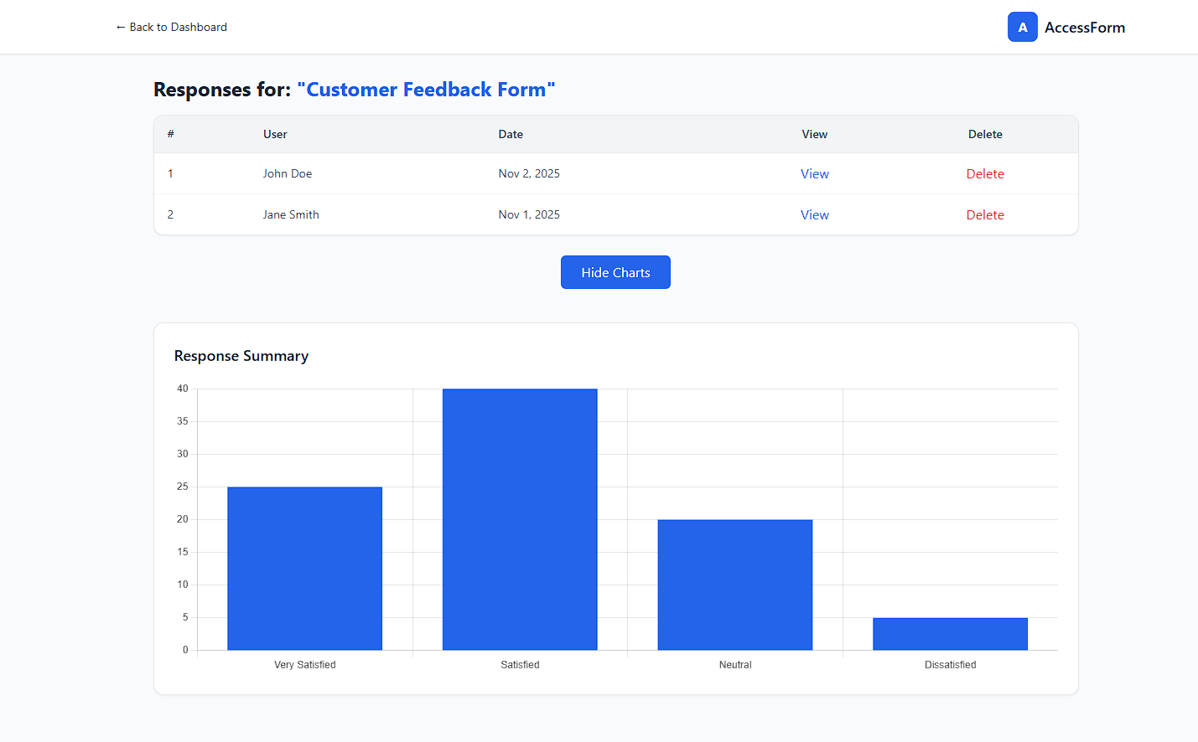
Figure 7.4
- Test Cases

Test cases are used to check whether our system is working correctly according to the requirements or not. With their help, we get the satisfaction that every function (use case) is performing exactly as it should, both in normal conditions and in difficult (exceptional) conditions.

In Access Form, test cases do not just check the system but also validate the accessibility features. For example, whether keyboard navigation is working correctly or not, if screen readers are able to read everything properly, and if the feedback received from the system is accessible or not. All these things are checked so that WCAG standards can be fully met.

